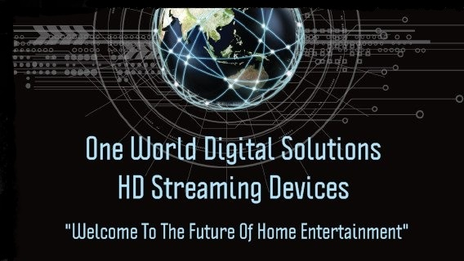

Customer User Guide for the

One World Digital Solutions HD Media Centre (Based on *KODI™/FTMC Technology.)
Kodi is a open source media center and FTMC is a fork ( another version like) they are interchangeable and we are now using FTMC but so as not to confuse these terms basically mean the same thing our One World media center build is a custom version of this media center we have made and is available only to One World customers.

Dear Recipient,
Thank you for choosing One World Digital Solutions™ for your new HD Streaming/Retro Gaming Device.

As with any new electronic device, it may take some time to feel confident with your new software. For your ease, this easy-to-use guide has been compiled of common questions and “issues”. Please be sure to consult this form before contacting your supplier.

HOW-TO GUIDE:
- Turn the machine off and on using either the button on the machine, or with the factory remote provided with the machine.
- Add on keyboard remotes, controllers, etc. may turn them off the machine but will not turn it back on. There is also an off/on switch on the front and or back of the unit depending on which one you own.

- When you first turn on your machine you will need to go to the settings/advanced area and link into your WIFI Network with your password or plug in Ethernet directly into the back of the unit. (When possible to do direct Ethernet it’s always best to do so.)
- Next go into apps in your settings area and uninstall Kodi if it is on the box and uninstall FTMC so that you can use our wizard app ensuring you have the latest version of our custom build.
- Do this by going to our Wizard app then choose install Kodi and choose new and it will install FTMC (which is what we now use instead of Kodi) and then choose install build and choose new which will install the latest version of our custom build.
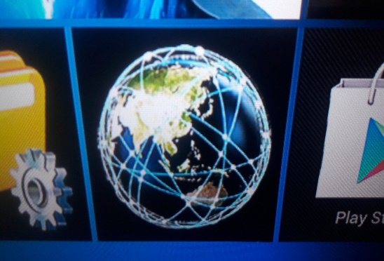
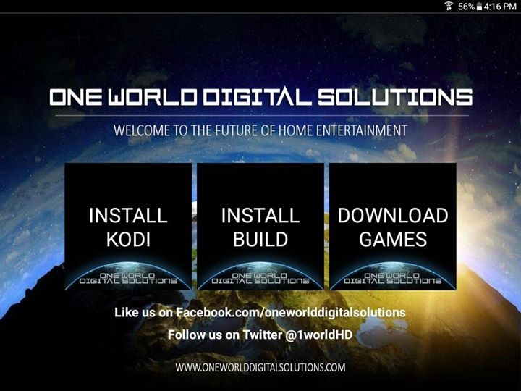
- There is numerous bonus apps that you can easily install on the machines which you install by simply clicking their tile.
- You will need to log into play store or use Aptoide to download some of them. Anything with a blue arrow is not installed simply click the tile and download/install.
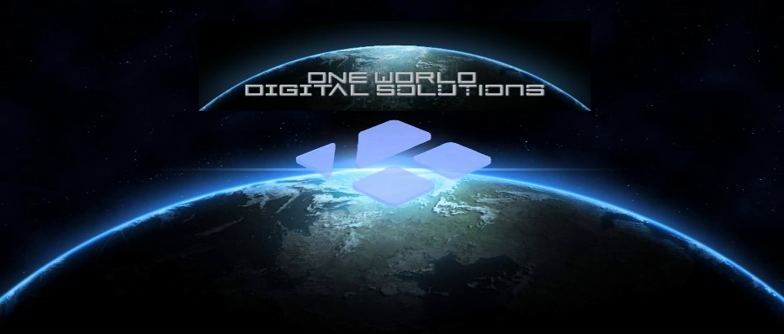
- Far left main tile One World Digital Solutions Media Centre(FTMC/Kodi™) is the open-source media centre with our custom One World Digital Solutions build and it is the main program and the ONLY program that we can customize, update and control via our One World Digital Solutions Wizard App. (The rest of the apps are strictly a bonus as they are just generic Android Apps so when they work and when they do not work is totally out of our control.)
- We do NOT recommend installing everything on the launcher as these are not all needed but just options. Installing everything on the launcher could overload your machine and cause it to not run properly please only install what you use and uninstall things you don’t use to keep your machine running at peak performance.

- Cloud TV is a Live TV App that has free live TV channels from all over the world! There is also a subscription option for more channels and more HD content but it is not needed although you may sign up if you wish.

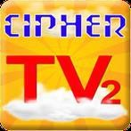
Is a Live North American Cable TV App. Which is no longer working and it will be removed from our launcher when we update the launcher in the near future.

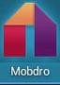

(Mobdro™) is another App for live TV, Sports and News from North America and Europe. Again, this app is a bonus and can stop working anytime so please don’t solely rely on this or any one bonus app for your content.

(Popcorn Time™) is basically just like Netflix™ but it is FREE! it has Movies and TV Series on demand.
- This app accesses torrents so it suggests a VPN you may use a VPN or just hit continue. Its technically downloading not streaming so we don’t advise using this app but use at your own risk.

- Also, however big the movie or show is that you are wanting to watch that much free space will be required on your drive or it will not play. For example, if you are going to watch a HD film that is 4gb you will need at least 4gb of free space on your machine in order for the film to play.

- (Show box™) Again is like Netflix™ but Free and it has Movies and TV Series on demand!
- This app has been around a long time and it’s a great bonus app that works 90% of the time. I suggest using it over popcorn time as they have the same content. Make sure that you are not using torrent but server and make sure you are STREAMING and not downloading!

- Inside our One World Digital Solutions media centre build of FTMC you will find everything from the above apps plus more, so you have numerous ways of accessing the same content!

- From your start screen inside the build you have different options, depending on what you would like to do Videos, Live TV, Sports, System, Settings etc.
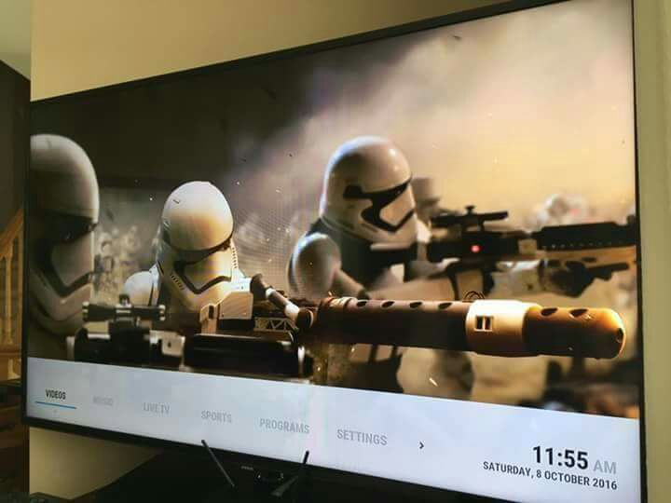
- I have provided subsections underneath each section to make things easier but these are all shortcuts for ease taken from various video add-ons.
- To see all the numerous video add-ons, push down on the videos area and choose video add ons or simply press enter on video and it will take you to video add ons and you can explore all the different add-ons for different programming.
- There is A TON of content there and it can be overwhelming at first but if you are looking for something particular, most add-ons have a search option once you open them up.
- In the Live TV area, you will find Mobdro, Live Hub,
UK Turk LIVE, Community Playlist, Vader HD, Globe TV, Vendetta, Freeview NZ , Made in Canada and others keep pushing over to see all the different live tv short cuts.
- Vader HD is a paid premium IPTV live HD addon. We have provided a customer community account so you can try out this service and see if you would like to get it for yourself. This account being shared means you may not be able to access it all the time and that it could go down or not be available at any time. To get your own account simply visit http://vaders.tv/watch/signup and create your username and password you will then go into the settings in Vader and put in your own username and password.
- Vader HD can also be used on your browser via your computer or phone and you have a 3 device max which means you can share an account with a family member.

- The FTV and Ivue guides are set up for numerous international channels, some you may have to set up by “choose” stream which will give you access to add-ons that are supported by that guide.

- You can add channels, add-ons or even sections of addons by hitting your “C” button on your keyboard remote or by hitting the menu button on the factory remote.

- Some streams may change over time and you will need to then remove stream and choose another (which again you will do by hitting your “C’ button.)

- Some channels will automatically ask you which add on you would like if the channel is supported by numerous different add-ons while others you must load manually.

- Again, you can bring up the context menu by hitting your C button on your keyboard remote and a list will pop up, choose stream or remove stream depending on which one you want to do.

- Sometimes a stream is down or not available, this is normal. Choose a different one.

TROUBLESHOOTING GUIDE:
- No connection? Before you enter ‘FTMC’ or any other App you must go to ‘Settings/Advanced’ when you first turn on the machine and find your network and put in your network password, it is the same as adding any other wireless device to your wireless network!
- If you go to Wifi and the launcher crashes then choose One World again and always and make sure to go to advanced in the settings area.
- No Wireless Network? Plug your Ethernet Cable into the back of the machine and then into your router! Also, make sure you have Ethernet turned on in the settings area.
- Time and Date not correct? Go to settings/advanced to the time and date area at the bottom and choose your correct time zone.

- Does FTMC kick you out when you try to open it? Try rebooting your system but if that does not help then this is usually caused by the internal hard drive being full.

- This is generally due to not doing your maintenance (clear cache/packages) You can try going into settings in the Android™ area and into Apps then find FTMC and go to clear cache and if that does not work then the only fix for this is a complete re-installation of Kodi™ You will uninstall FTMC and then use the One World
Wizard™ App to install FTMC and then once finished you will choose done and then run install build and choose new

- So PLEASE do your maintenance by clearing your cache AND packages often! (We now have a addon which does it for you automatically but it does not hurt to do it manually here and there still.)
- If your keyboard remote isn’t working? Have you taken the USB receiver out of the back of the remote and put it into the back of your machine? Don’t forget to charge the remote! There is an off/on switch on top, make sure it is on. Also if its not working well try using another USB port.

- If your stream stops working. Restart it. Sometimes this happens during movies or live streams here and there, it will usually ask you if you would like to resume if it is in a movie but if not then you can push up arrow to jump 10 minutes ahead or down to rewind 10 minutes.

- Screen Frozen? Either stop the stream or if that does not work then restart the machine. Hold down the button on the unit or the power button on the remote provided with the machine. The Keyboard remote does not have this option. (You may need to hard reboot which is unplug the power cord of the unit for 20 seconds.)

- If a program takes too long to load, and you can’t cancel it. If you wish to wait, it will usually stop or load eventually. If it is taking longer than one or two minutes it will be faster to just restart your machine. This does happen sometimes especially with slower Internet connections.

- Need a Tutorial Guide? We have Tutorial Video addons included in the build that you can easily access. Noobs N Nerds has some as well as there is numerous others on Youtube.

- Is your unit buffering a lot? You may need faster internet, check your internet speed by doing a speed test we have provided one for you on the home screen of the launcher.

- Anything under 10Mbps may struggle with live streams especially higher quality ones. But anything over 6 Mbps should be fine for all the on-demand movies and TV shows. 25Mbps and up should have no buffering problems whatsoever even for HD content and if it does then it is usually the source. There is numerous ways to access the same content so look for and use another source.

- If you are still having speed or buffering issues you may need a better router or Wi-Fi extender.

- Also numerous devices turned on in the house take bandwidth as well as some high-powered microwaves and cordless phones can also effect WIFI speeds.

ADDING/DELETING YOUR OWN PROGRAMING:

- Remember your machine is totally customizable and you can choose to use different builds or you can make your own build.
- If you would like to try out different builds we have provided Ares Wizard in the program addons area which you can easily install numerous other builds. (Please note we will not be able to give customer support on any other builds but our One World build.
- In the private customer support group everyone is using the One World build and if you choose another build but decide you want to go back to using our build you simply uninstall FTMC or Kodi (whichever your running) and then use our wizard app to install again.

- To add more programing add-ons, you will go into either Add-ons or Programs and at the bottom of the list, click ‘GET MORE’ you will then see a huge list of add-ons from all over the world that can be installed.

- Once you find an add-on you like, press ‘Ok’ and you will be prompted to install. It will automatically download/install and you will find it in the addons area from that point on.

- If you would like to delete any ‘ADD-ON’ press the ‘C’ button to bring up the menu. If you are using the regular remote press ‘menu’. A pop up menu will appear. Go to ADD-ON information and it will prompt you to choose an option. Choose uninstall and now it will no longer be in the add-ons list.

SYSTEM/SETTINGS

- In ‘FTMC’ you can access System from the main menu area. Here you can change different items on your system. Once you click on System, you can follow the prompts to explore and change different system settings and options.
- Before entering ‘FTMC’ you can access the Android™ settings on your main system menu by going to settings and then advanced. In here you add your Wi-Fi, change the date/time zone, language, etc… This is the area for all options for your Android device. You can also adjust your screen settings if needed.

- If you have changed your box to a point where you are unhappy or clicked something that has made it difficult to use, you can restore your FTMC to its original condition by running the One World Wizard App
- Go into Android settings and then into apps find and uninstall Kodi™ or FTMC once you have uninstalled you then go to the One World Wizard App™ and reinstall Kodi™/FTMC once finished you will choose install build then choose new when prompted. Once it loads to 100% it will say the build has been successfully updated and now your good to go! If it does NOT say successfully updated your build may not work properly so please do this again.

- Remember: Unless you are an advanced user, do not play around too much with the System or Settings if you do something that seems to have changed things for the worse, follow the Restore directions above.

- Remember: Whatever download speed you have is shared between anyone using the same connection, if someone else in the household is playing a game with their friends on Xbox Live then this will lower the speed, the same goes with anyone streaming content in another room.

Downloads (especially torrents) can use up a lot of bandwidth, and although all the systems are download capable we DO NOT recommend downloading as it is ILLEGAL and there is no need as you can simply stream everything from your machine. That is the great thing about these machines is that you do not need to download because it is there “in the cloud” for you to access at any time.

Is there a fix for buffering?

- There is not one way to fix buffering, but there are a number of mandatory items to check off to ensure that it isn’t your internet connection causing the buffering:
- Make sure your Kodi box is hard-wired when possible. Wireless connections get a fraction of the internet speed of the same wired connection.
- Make sure you have at least 5mbps internet speed for streaming movies/TV or 10mbps internet speed for live streaming. This isn’t exact, but are general numbers to help you out.
- Try a different source. For a live event, a stream can easily become overloaded and will buffer no matter what because the source itself is overloaded. For movies and on demad TV, different file hosts have different speeds in different countries. For example, openload may be quick in one area, but clicknupload may be fast in another. Find what host works best for you.
- Add-on X isn’t working, how can I fix it?
- If the add-on takes streams from a single source (M4U, 123Movies, etc), the source could be down and you’ll have to wait for an update. If the add-on is multi-source (Covenant, SALTs etc), there are a number of reasons that it may not work: you haven’t installed it directly from the repo, you are picking an uncommon movie/TV show that has no streams available, or a number of other reasons.
- We update our build usually at least once every 4-6 weeks at which time we delete and remove old addons no longer working and we install and include new addons.
- Things are constantly evolving and changing and that is the beauty of our wizard app is it allows our customers to have the latest and most up to date content available without needing to pay to have their box reloaded like others do or to have to learn how to constantly update their box themselves.
- Keep in mind we always encourage people to know about and learn about how to take control of their machines because in the end we are ALL end users and we do not provide any of the content we simply sell you the machine and our custom software which allows you to get more from your box and do our best to provide our customers with the best and easiest ways to have access to as much content as possible.
- One World Digital Solutions™ is committed to providing you with the highest level of customer satisfaction possible. If you are having an issue this user guide does not cover, then we are delighted to hear from you.

You can either send me an email at
chris@oneworlddigitalsolutions.com or add me on skype:
“oneworlddigitalsolutions” and I will respond to you as soon as possible.

Please check us out on http://www.facebook.com/oneworlddigitalsolutions and leave a 5-star review!

We also have a NZ page at www.Facebook.com/oneworlddigitalsolutionsnz
And follow us on @1worldHD for the latest information and tips!

Don’t forget to join our Customer Support Page! ☺ https://www.facebook.com/groups/245943315820990/

Thank you for your order and I hope you love your new HD Streaming device!

Chris Marshall Owner/Operator www.oneworlddigitalsolutions.com

www.oneworlddigitalsolutions.nz

www.oneworlddigitalsolutions.ca

